ISO 27110 Compliance for Log360
Strengthen cybersecurity and meet ISO 27110 compliance with Log360.
Region: International | Type: Cybersecurity Framework, Industry Standard, Incident Management | Category: Compliance | Pricing: Free

Overview
The ISO 27110 compliance extension in Log360 helps organizations meet ISO/IEC TS 27110:2021 Cybersecurity Framework Development Guidelines, the international technical specification for building cybersecurity frameworks applicable to organizations of any type and size by providing centralized log management, continuous threat monitoring, and incident response capabilities. The platform supports ISO 27110 requirements for asset identification, access control protection, data security, secure configuration, continuous threat detection, audit logging, incident response, and recovery planning.
For Identify: Asset Management and Risk Assessment, Log360 monitors system events, tracks computer account activities, and audits software inventory changes to support comprehensive IT asset management and risk visibility. To address Protect: Access Control and Identity Management, the platform monitors user authentication, privileged account access, and failed logon attempts across Windows, Unix, and Active Directory environments to enforce access control requirements. The extension also supports Protect: Data Security and Information Protection by providing capabilities that monitors file changes, USB storage events, removable media usage, and registry modifications to detect data exfiltration or unauthorized data manipulation attempts.

Key Features
- Protect: Secure Configuration Management: Log360 monitors policy changes, Group Policy updates, software installation events, and network device configuration modifications to detect unauthorized configuration drift.
- Detect: Continuous Monitoring and Threat Detection: Log360 provides real-time threat detection for Windows, Unix, and network environments, correlating antivirus, FireEye, and Trend Micro alerts to identify active threats.
- Detect: Audit Logging and Forensic Readiness: Log360 centralizes event logs from operating systems, databases, and identity platforms, delivering tamper-evident audit records for incident analysis and regulatory review.
- Respond: Incident Response and Analysis: Log360 correlates threat detection alerts, monitors network attacks, and aggregates cloud security incidents to support rapid investigation and response.


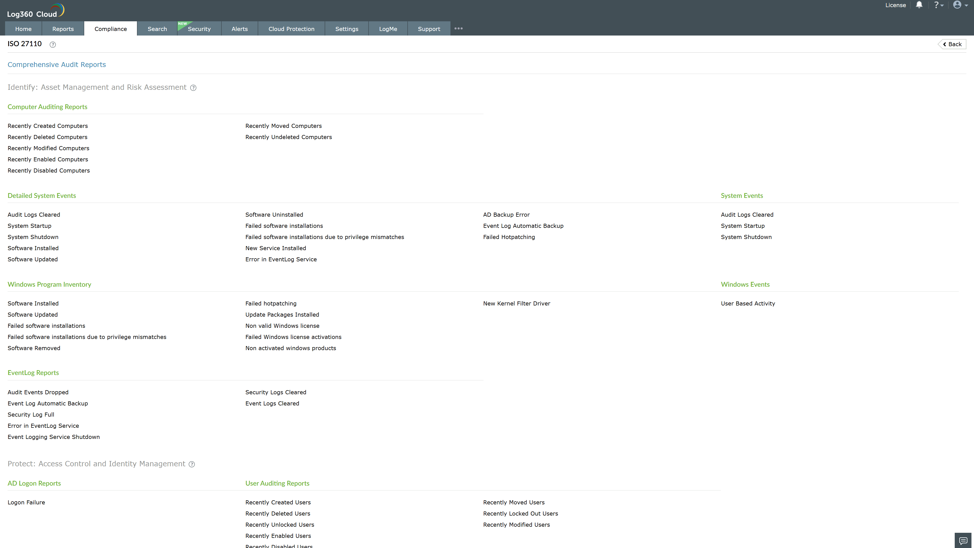
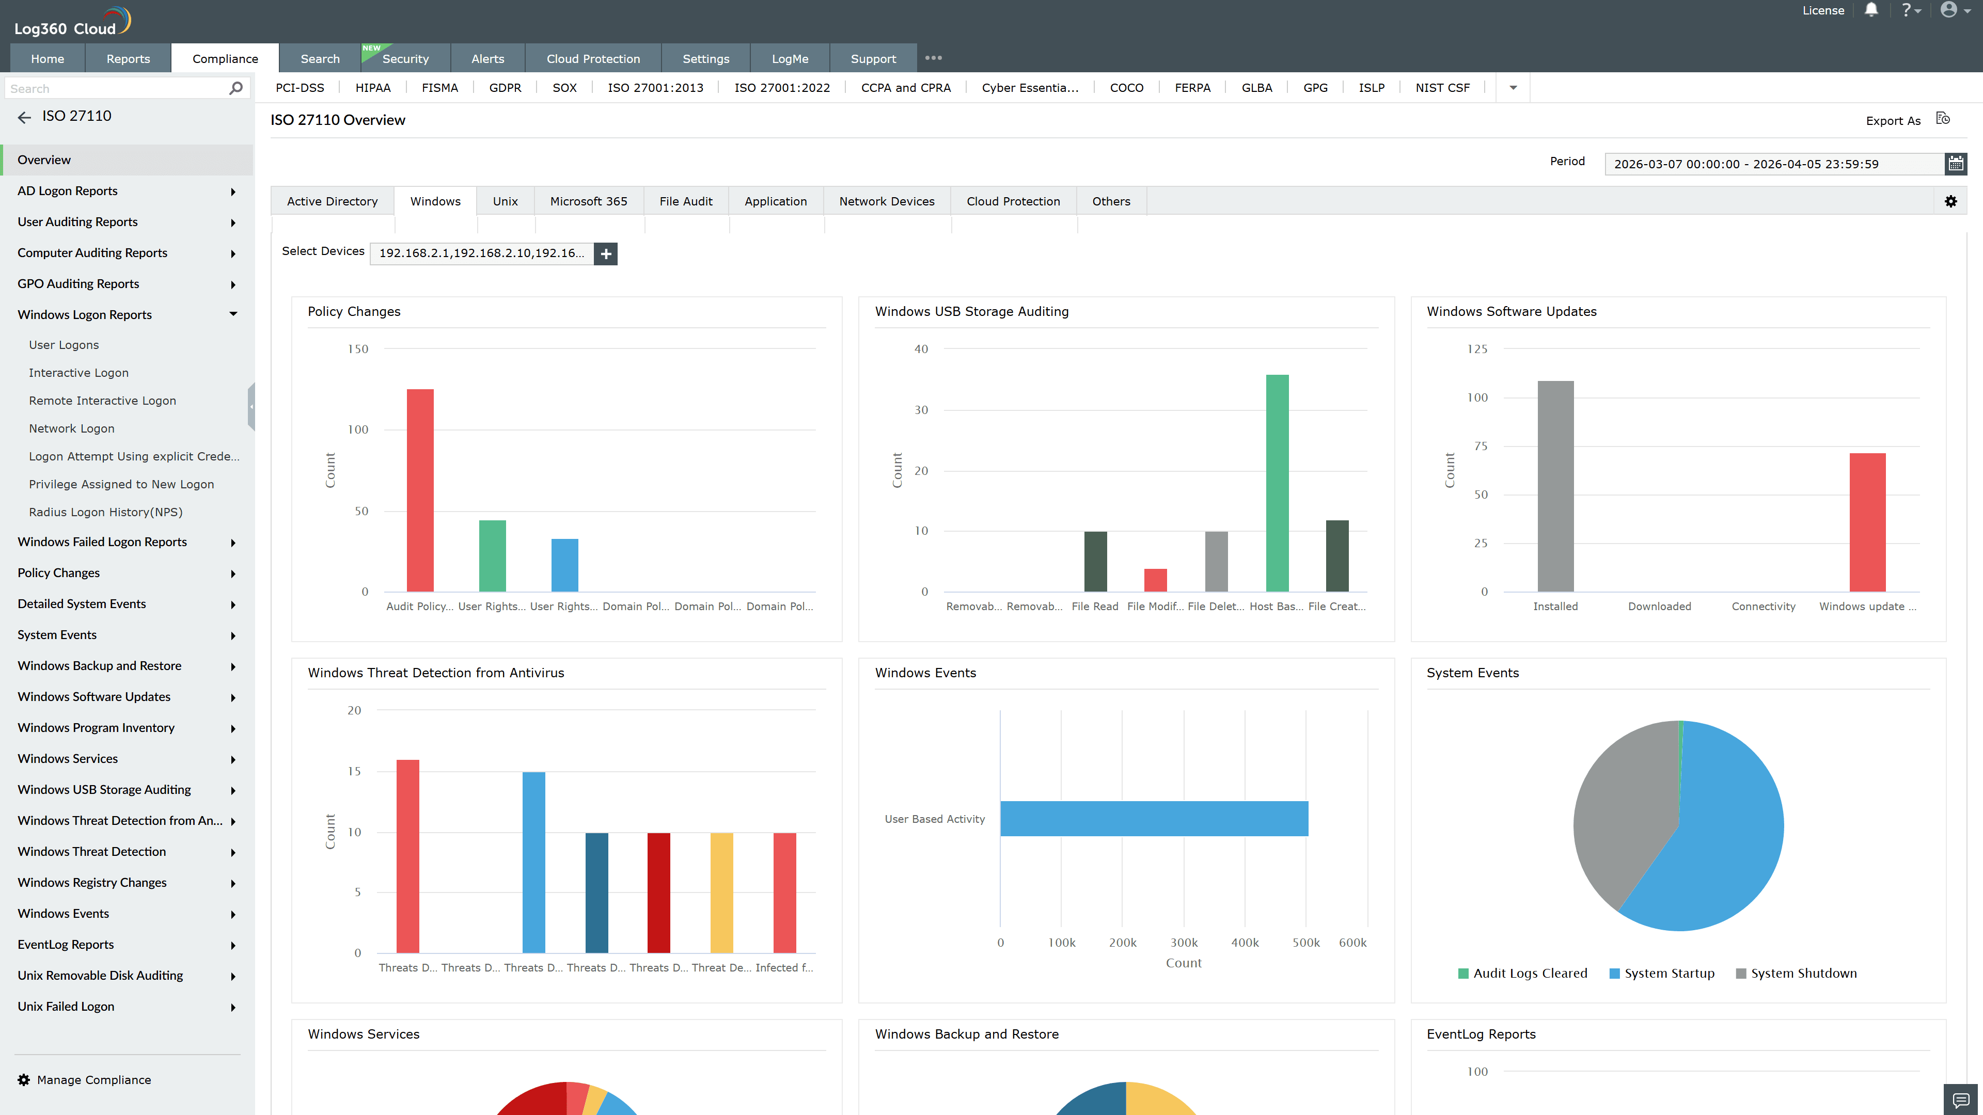
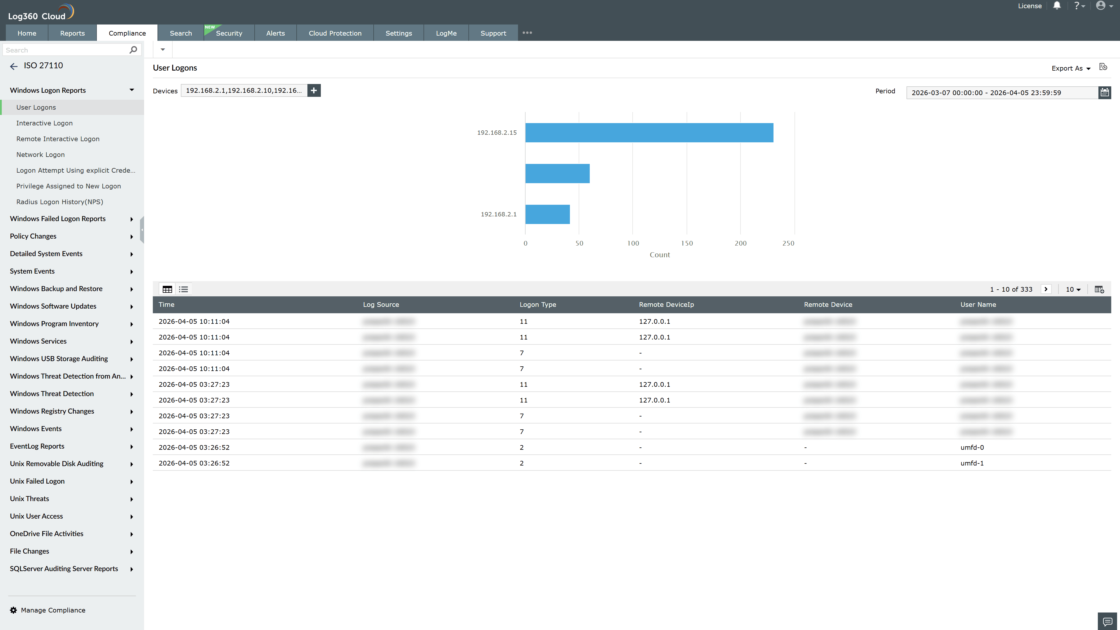
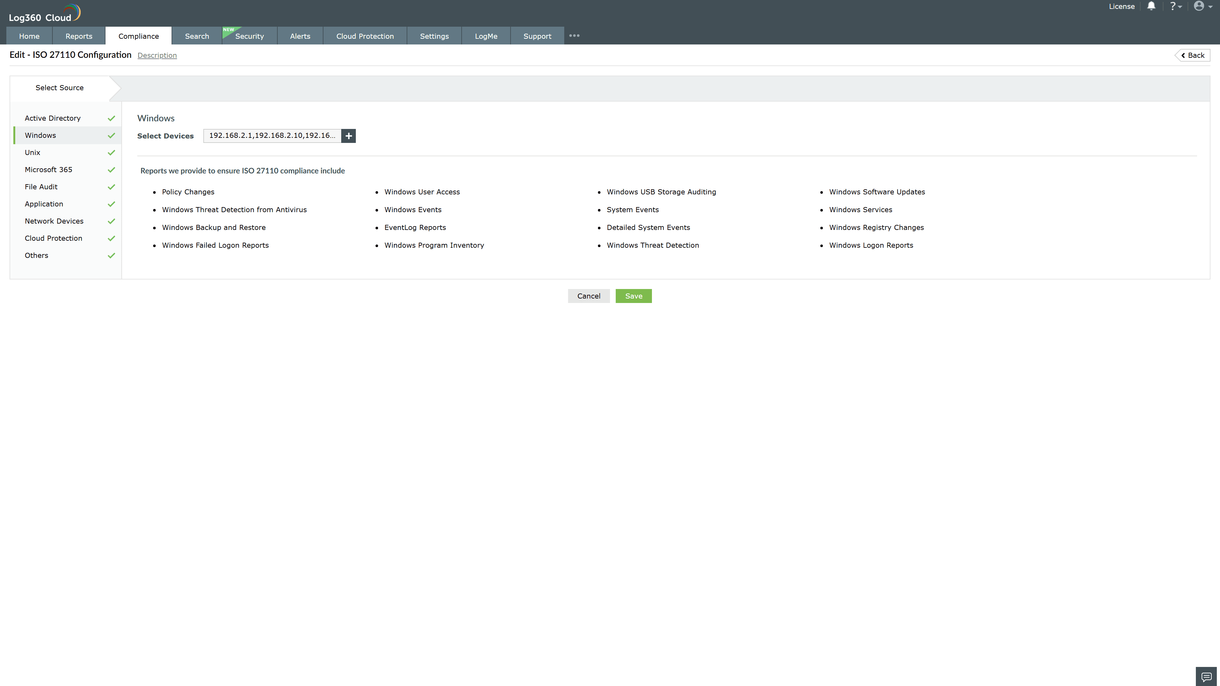
Valid Submission : Yes
Supported Editions : Free, Basic, Standard, Professional, MSSP
Help Document : https://www.manageengine.com/log-management/help/integrations/compliance-extensions.html
Help Video : Not provided
Tags : Log360, Compliance, Privacy monitoring, Data privacy, Regulatory compliance
Supported DCs : US, IN, JP, CA, AU, UK and EU
Privacy Policy:
Terms of Service:
Release Notes:
Predefined reports for the ISO 27110.

